Job Description  Member of the Board of Advisors | 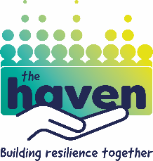

We are seeking new members for the Board of Advisors for The Haven, a grassroots project helping young people increase their mental resilience.
Since our inception in 2017, The Haven has found ways to deliver transformative tools and strategies to young people, whose lives are diminished by early onset mental health issues. Our support groups and school courses create safe spaces for those young people and empower them to manage their own mental and emotional wellbeing.
This is an exciting time for The Haven as we aim to significantly increase the reach and impact of this much-needed work.
Are you:
- Passionate about improving the lives of young people?
- Great at working with a team, made up of both dedicated staff and committed volunteers?
- Highly sympathetic to the values and ethos of the Christian faith?
If so we’d love to hear from you. We are currently looking for individuals who can demonstrate strengths and capabilities in the following areas:
- Finance – Have you got experience in helping organisations to manage the financial side of their operations? Can you assist our team to ensure that we are efficient and effective in our forecasts and budgeting?
- Fundraising – Have you got the skills and enthusiasm to help us raise essential funds, through grant applications or running events?
The Board of Advisors works closely with the Haven Director to develop strategies for expanding the work of The Haven and ensuring that our growth is undertaken in a financially responsible manner. Being a Member is voluntary, with an estimated time commitment of 1 day a month.
This is an exciting time for The Haven and a valuable opportunity for individuals who are passionate about making a lasting difference to young people.
If you are interested in applying or learning more about the opportunities available, please get in touch by emailing claire@thehaven.uk

